FOR IMMEDIATE RELEASE
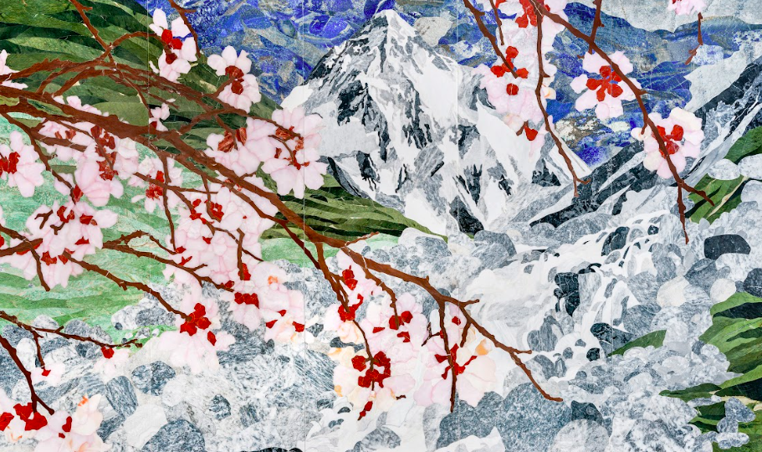Garden 4 Hamra Abbas

FRAGMENTS OF FOLKLORE
A Landmark Exhibition Redefining Artistic Accessibility in Saudi Arabia

- JAX District, Riyadh, Saudi Arabia
- April 30 – May 12, 2025
- Presented by THAA, MIR’A, and TRIYAD

Fragments of Folklore is a world-class exhibition presenting cultural identity through art, bridging tradition and contemporary practice, and redefining the accessibility of artistic expression in Saudi Arabia and beyond.
The exhibition marks a pivotal moment in the evolution of contemporary art in Saudi Arabia as the kingdom reshapes its cultural landscape through its Vision 2030 reform plans. Fragments of Folklore reflects this paradigm shift via its featured artists (Lulwah Al Homoud, Raeda Ashour, Rashid Al Khalifa, and Hamra Abbas) who all explore the ongoing tension between tradition and reinvention.
Notably, three-quarters of the artists featured in Fragments of Folklore are female, including two Saudi artists (Al Homoud and Ashour); which aligns with the Saudi Arabia Vision 2030 plans to increase female empowerment and representation.
This exhibition, which takes place in Riyadh’s JAX District (also known as the epicenter of Saudi Arabia’s burgeoning contemporary arts scene), also marks a first-of-its-kind collaboration between three pioneering institutions – THAA (Saudi Arabia), MIR’A Art (Paris/Middle East) and TRIYAD (Belgium) – all uniting their expertise to bridge local and global artistic discourse.
At a time when the Middle East’s artistic landscape is expanding at an unprecedented pace, Fragments of Folklore isn’t just an exhibition – it is a cultural statement, an invitation to rethink accessibility, identity, and the evolving role of art in a rapidly transforming society.

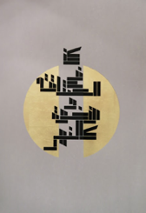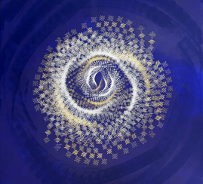
Rumi #4 Lulwah Al Homoud Al Moez Lulwah Al Homoud

FRAGMENTS OF FOLKLORE: FEATURED ARTISTS
Folklore is often thought of as an oral tradition – stories, myths, and legends passed down through generations. Yet, folklore is more than narrative; it is also a language of symbols, patterns, as well as a conduit for conduit for cultural preservation. Whether it’s Bruegel’s peasant scenes, Goya’s dark mythologies, Marc Chagall’s folkloric dreamscapes or Frida Kahlo’s deeply personal narratives, folklore has served as both an anchor to history and a catalyst for innovation in art.
In Fragments of Folklore, Hamra Abbas, Lulwah Al Homoud, Rashid Al Khalifa and Raeda Ashour all engage with elements of their cultural heritage, translating them into contemporary artistic expressions. Here, folklore is not a static relic of the past but a dynamic archive of identity, reshaped and reimagined across time and geography. The exhibition coincides with Saudi Arabia’s Year of Handicrafts 2025, an initiative that foregrounds artisanal heritage while redefining its relevance in contemporary practice.
Each artist works with fragments of inherited knowledge – whether through geometry, calligraphy, materiality, or abstraction. Their works echo the past while asserting their place in the present, engaging with motifs and forms that have carried meaning for centuries but are now filtered through a modern lens.
By bringing these four artists together for the first time, Fragments of Folklore creates a landmark cross-cultural conversation on tradition, symbolism, and storytelling.
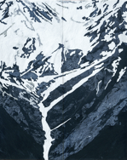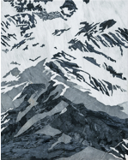
Aerial Studies #2 Hamra Abbas Aerial Studies #3 Hamra Abbas

FRAGMENTS OF FOLKLORE: SAUDI ARABIA AT A CROSSROADS
Fragments of Folklore stands as a defining moment in the evolution of contemporary Saudi art, reflecting the Kingdom’s dynamic cultural transformation under Vision 2030.
Saudi Arabia is entering a new era of cultural ambition and artistic innovation. Once known primarily for its economic power and religious heritage, the kingdom is now emerging as a global hub for the arts. With a thriving tourism industry, record investments in sports – including hosting the 2034 FIFA World Cup – and the introduction of international entertainment, Saudi Arabia is reshaping its identity on the world stage. At the heart of this transformation is a deep commitment to high culture, signalling a new chapter in the kingdom’s creative and intellectual evolution.
At the forefront of this shift is Riyadh, which is set to host the Louvre Riyadh, a landmark $500 million project that strengthens Saudi Arabia’s ties with France’s most renowned cultural institutions. This follows the Centre Pompidou’s expansion into AlUla, further reinforcing Saudi Arabia’s role as a key player in the global arts scene. The kingdom has also made a historic entrance into the international art market, with Sotheby’s holding its inaugural auction in Saudi Arabia in 2025, demonstrating the growing demand for fine art in the region and its rising influence in the global art economy.
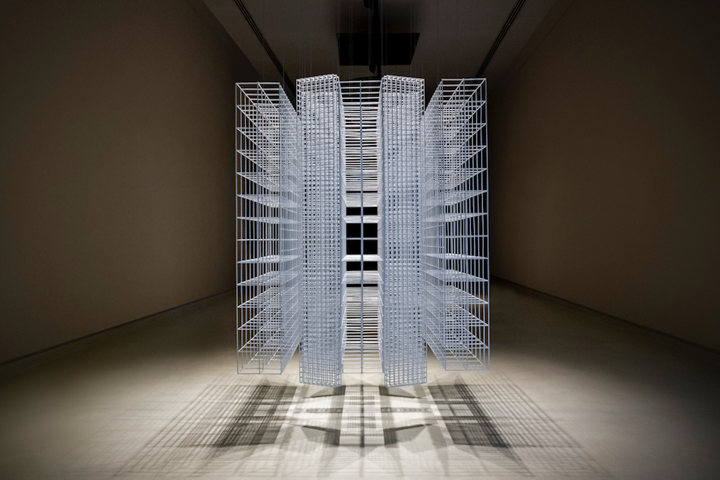
Mobile Column VII Rashid Al Khalifa

Alongside these developments, Saudi Arabia is hosting an unprecedented wave of world-class exhibitions. Desert X AlUla, now a staple in the international art calendar, continues to bring ground-breaking land art to the country’s wondrous desert landscapes. Simultaneously, The Islamic Arts Biennale, running until 25 May, is offering an extraordinary exploration of Islamic heritage and contemporary interpretations, coinciding with Fragments of Folklore, a cultural showcase that delves into the rich traditions and narratives shaping the region’s artistic identity.

Historically, large-scale exhibitions in the Gulf have focused on imported western narratives; Fragments of Folklore reverses this trajectory – elevating regional voices, redefining creative accessibility, and ensuring that the next generation of artists and audiences engage with art not as an exclusive privilege, but as an intrinsic right.

Fragments of Folklore also directly aligns with the kingdom’s ambition to become a global cultural hub, placing its contemporary artists on the world stage and creating an infrastructure where art is not just displayed, but actively lived, debated, and reimagined.
With a young, ambitious, and globally connected generation leading the charge, Saudi Arabia is experiencing an artistic renaissance – one that is not only redefining its own cultural identity but also positioning the kingdom as a leading force in the global art world. This dynamism is reflected in the location hosting Fragments of Folklore: Riyadh’s thriving JAX District, the epicenter of Saudi Arabia’s contemporary arts scene and home to acclaimed artists, galleries, creative agencies and SAMOCA (the kingdom’s first contemporary art museum).
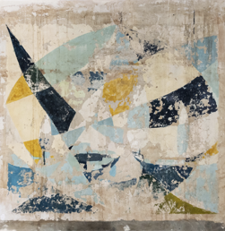
‘Wall Painting’ Rashid Al Khalifa

BEYOND THE EXHIBITION: A MOVEMENT FOR ARTISTIC ACCESSIBILITY
More than an exhibition, Fragments of Folklore marks the beginning of a cultural movement:
- Mentorship & Visibility – Supporting emerging artists in Saudi Arabia by offering mentorship, curatorial support, and institutional partnerships.
- Global Dialogue – Bridging Saudi and MENA narratives with international audiences through collaborations in Paris, Brussels, and beyond.
- Sustainability & Representation – Ensuring that cultural heritage is not just preserved but actively reinterpreted for future generations.
- A shift from Euro-centric to Multi-centric – By bringing together artists from Saudi Arabia, Bahrain, and Pakistan, Fragments of Folklore ensures Middle Eastern and south Asian artists are shaping their own artistic discourse. The exhibition could also be seen as part of a larger art-world shift towards decolonizing narratives.
- Accessible Art Ownership – The exhibition will also feature a curated Art Store, making prints and smaller works by emerging artists available at reasonable prices—allowing a broader audience to engage with and own contemporary art.
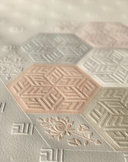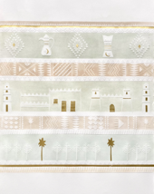
Detail Allah Series 2 Raeda Ashour. Untitled Raeda Ashour

JOIN THE CONVERSATION

Fragments of Folklore is a unique opportunity to experience a bold reimagining of cultural identity, artistic innovation and accessibility in contemporary art. The exhibition also marks a time when Saudi Arabia is asserting its place in this historic trajectory – not as a passive observer of global art history, but as an active participant shaping its future.

This is more than an exhibition. This is a cultural reckoning.
JOIN US.

- Ends -

EDITOR’S NOTE:
April 30 – May 12, 2025
JAX District, Riyadh, Saudi Arabia
Press Preview 28th April: By Invitation Only
For interviews, media access, and further information, please contact:
GIFFORD PR
For images please click here

ABOUT THE ARTISTS:
Hamra Abbas (Pakistan)
An internationally recognised artist who, by merging classical and contemporary perspectives, challenges historical and religious iconography. Incorporating miniature painting, marble inlay, and historically rooted craftsmanship, she demonstrates how artistic heritage is a living entity that can be transformed, layered, and reinterpreted. Abbas has been featured in major biennales and museums, including the Venice Biennale and the Sharjah Biennial.

Lulwah Al Homoud (Saudi Arabia)
A pioneer in mathematical calligraphy who transforms the Middle East’s rich linguistic traditions into strikingly modern visual languages. By using deconstructed calligraphic elements, she reveals the underlying logic and rhythm of Islamic aesthetics, reinterpreting its timeless language through modern expression. Al Homoud is also founder of the Riyadh-based LAHAF Art Foundation, which nurtures artistic talent within Saudi Arabia. Her works are part of permanent collections at the British Museum and LACMA.

Rashid Al Khalifa (Bahrain)
An artist known for his innovative interplay between light, architecture, and form, challenging spatial perception in contemporary Gulf art. His geometric compositions recall the intricate decorative traditions of Islamic art, where patterns served as a means of visual storytelling beyond the written word.

Raeda Ashour (Saudi Arabia)
An artist renowned for reimagining Islamic motifs and architectural elements, merging tradition with contemporary aesthetics in dynamic visual compositions. Her work reconstructs the rhythmic patterns of calligraphy and ornamentation, preserving their aesthetic essence while reshaping them into contemporary compositions that harmonize past and present. After a period of relative quiet, this exhibition reintroduces the folkloric essence of Ashour’s artworks, breathing new life into her distinctive visual language.

ABOUT THE COLLABORATING INSTITUTIONS:
THAA
THAA is an art initiative focused on making creativity accessible and inclusive. It provides artists, writers, and creatives with platforms to explore and showcase their work. As a connector, THAA fosters the exchange of knowledge and artistic expression across generations, bridging artists with the wider community.

MIR’A Art
A Paris-based hub, championing MENA artists in the European cultural landscape. Through interdisciplinary collaborations in performing arts, music, cinema, and visual art, MIR’A Art shapes cross-cultural representation.

TRIYAD
A Belgium-based curatorial platform rethinking the role of exhibitions in contemporary art. TRIYAD’s innovative approach places neuro-aesthetics, research, and experimental curation at the centre of artistic engagement.

KEY QUOTES
Curatorial Statements THAA - MIR’Art - TRIYAD

The Living Legacy of Folklore
"We see folklore as a living, shifting narrative—one that connects past and present while shaping future identities. Fragments of Folklore reimagines tradition in a contemporary way, celebrating the evolving stories that define who we are and who we become." — Hassan bin Khalid Al-Qahtani, Founder of THAA’

On Art & Identity
“Through MIR’A, our core mission has always been to connect East and West and Fragments of Folklore is part of this movement. For generations, the narrative of our culture has often been told from an external perspective, but now we have the opportunity to share our story in our own voice. By presenting it through our own lens, with THAA and TRIYAD, we ensure that its richness and depth are fully recognized and appreciated.” — Nadine El Guiddawy, Curator & Co-Founder of MIR'A Art

Saudi Arabia’s Cultural Evolution
“This exhibition is more than a presentation of works—it is a movement that brings visibility to artists shaping the artistic landscape of Saudi Arabia and beyond. By bringing these voices to the forefront, Fragments of Folklore actively contributes to shaping art history, ensuring that heritage is both preserved and dynamically reimagined for future generations.” — Lisa De Boeck, Curator & Founder of TRIYAD

CURATORIAL COMMENT

In Fragments of Folklore, heritage is not preserved in a glass case; it is a fluid and living entity. The exhibition does not seek to define folklore in rigid terms but instead presents it as an ongoing dialogue between past and present, a continuum of interpretation and reinvention. Each artist offers a fragment of this larger story, inviting us to reconsider what we inherit, what we keep, and what we transform.

This dialogue between tradition and reinvention extends into the exhibition design itself, drawing inspiration from the labyrinthine layouts of the Najd region. The space is conceived as a labyrinth—fragmented yet interconnected, much like folklore itself. Each narrative stands alone while remaining part of a greater whole, guiding visitors on a journey of discovery. Narrow pathways and hidden openings create moments of intimacy and revelation, while a central column serves as a symbolic anchor, grounding the exhibition in heritage while embracing change.

Material choices further enrich this experience: Acacia wood forms the structural framework, recalling the endurance of tradition; parchment evokes the fragility and resilience of oral storytelling, casting shifting shadows; natural pigments and textures reference ancestral craft, embedding history into the very fabric of the space. This immersive environment amplifies the contrast between past and present, allowing contemporary works to engage directly with the architectural and material heritage they reinterpret.

